A word from your Pastor…

“Give thanks in all circumstances.”– 1 Thessalonians 5:18

November marks one of my favorite holidays. It combines time with family, food, and the blast of colder weather. November is a time of Thanksgiving. Thanksgiving is a time when we can all look back and reflect on God’s faithfulness and provisions in our lives.

Johnson Oatman penned a familiar hymn, “Count Your Blessings.” We sing this hymn frequently and know the lyrics, but may we be encouraged to live out its meaning. This Thanksgiving season, may we count our blessings literally number or list the innumerable ways that God has blessed us. I am sure that if we all got out a pen and a notepad, we would be able to fill it with many ways that God has blessed us and our families. As Johnson Oatman says, “Count your many blessings, and it will surprise you at what the Lord has done.”

In Him,
Bro. Justin

Thoughts from your Family Minister…

Happy Fall Yall!

Fall is in the air (winter this week)! This time of year makes me think of Pumpkin Pies, Pecan Pies, and fall foods all over! Getting ready for Thanksgiving is on tap for most people right now. Fall festivals are everywhere you turn these days!

Speaking of Fall Festival…Ours will be November 11th starting at 2pm and goes no later than 6. We are still looking for some help to make it happen. Sunday schools have volunteered to run the booths, ladies to serve food, and some men to help cook. Willing to help see me to volunteer!

I have ordered some Advent devotional guides for youth & children and families. I will give these out before December 1st . Make sure you get one before then.

I would like to give a heart filled “Thanks” from Karen and I for the Pastor appreciation lunch and the gifts and cards. You all know how to make us feel loved! Of course, you all do that all year long by the support you give to the kids and youth programs. We love our Pine Grove folks!

Because of Christ,
Bro D.

A Message from your Music Minister…

My lips will shout for joy, when I sing praises to you; my soul also,
which you have redeemed. Psalm 71:23
The Choir is preparing for our Christmas music presentation Sunday
morning December 11th at 10:30 am. Come and join us for a time of
reflection and celebration remembering our Savior's birth.

In Christ,
Bro. Benjy

NOVEMBER BIRTHDAYS

Happy Birthday to You!

2 – Dave Suttora 12 – Wendy Hunter
2 – Debbie Songy 12 – Pat Reynolds
4 – Gracie Stewart 12 – Carrie Spiers
5 – Sandra Prevot 14 – Pat Suttora
6 – Jacob Kelly 23 – Sherrill Reynolds
9 – Melba Seal 27 – Chuck Simmons

If your Birthday isn’t listed, please contact the Office
so we can add your Date of Birth to our system.

AVERAGE ATTENDANCE FOR OCTOBER
Sunday School: 78
Wed. Night (Student Ministry/Nursery):
Super Seniors: 14
Iron Sharp: 8

SANCTUARY FLOWERS FOR NOVEMBER
NOVEMBER 5: Veazey Family
NOVEMBER 12: Dianne Sellers
NOVEMBER 19: Thanksgiving
NOVEMBER 26: Hanging of the Green

NURSERY TODDLER’S CHURCH
November 5: Heather Thompson November 5: Jessica ONeal
November 12: Carly Spiers November 12: Marlie Anderson
November 19: Erica Guidry November 19: Karen Balch
November 26: Wendy Hunter November 26: Lana Cochran

COUNTERS
NOVEMBER 5: Heather Thompson, Sandra Seal
NOVEMBER 12: Wendy Lee, GeAnna Ladner
NOVEMBER 19: Lesa Haselmaier, Wendy Hunter
NOVEMBER 26: Dianne Dusang, Jamie ONeal

Sunday:
Fellowship (Coffee & Donuts) – 9:00 a.m.
Sunday School – 9:30 a.m.
Morning Worship Service – 10:30 a.m.
Evening Worship – 6:00 p.m.

Tuesday:
Iron Sharp (Men’s Bible Study) 8:00 AM

Wednesday:
Prayer Meeting/Bible Study 10:00 AM(Adults) and 6:30 PM (All Ages)
______________________________________________________________________
CALENDAR OF EVENTS

1 – Deacon’s Meeting – 7:30 pm
6 – Heaven’s Helpers – 6:30 pm
9 - Super Senior Lunch – 11:00 am Lester’s in Picayune
11 – Fall Festival – 3:00 pm – 6:00 pm FOOD/GAMES/FELLOWSHIP
12 - HARVEST DAY! High Attendance in SS and Church/Guest Speaker Dr. Nix
16 – Food Pantry – 10:00 am
19 – Deadline to turn in “SHOEBOXES”
19 – Deadline to turn in forms for Poinsettia’s
20 – 24 – The Office will be closed the week of Thanksgiving
23 – HAPPY THANKSGIVING
26 – “Hanging of the Green” Service/Lord’s Supper
Thanksgiving & Christmas Meal in the CAB/Lottie Moon Auction

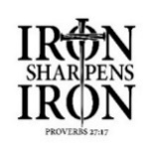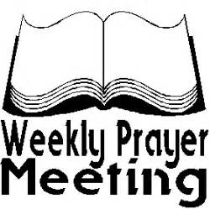
Every Tuesday @ 8:00 am Every Wednesday 10am & 6:30pm November 16th

For Visitors For the Pearl

The Chime Newsletter

34 Pine Grove Road – Picayune, MS 39466
Church Office: (601) 798-3645 – Fax (601) 798-8246
Office Hours: Tues., Wed., & Thur. (8:00 am – 3:00 pm)
E-Mail: pgbcpicayune@gmail.com
Web Site: www.pgbcpicayune.com

Pine Grove Baptist Church Ministry Team:
Rev. Justin Anderson, Pastor
Donald Balch, Minister to Families
Benjy Rigney, Minister of Music
Jamie ONeal, Church Secretary
Crystal Ramos, Financial Secretary

NOVEMBER 2023

SUNDAY | MONDAY | TUESDAY | WEDNESDAY | THURSDAY | FRIDAY | SATURDAY
Choir Practice  Every  Sunday  At 5:00 pm |  | Iron Sharp  Every Tuesday @ 8:00 am | Morning Prayer Meeting  Every Wednesday  @ 10:00 am
 |  |  | 1  Deacon’s Meeting  7:30 pm | 2 | 3 | 4
5 | 6  Heaven’s Helpers  6:30 pm | 7 | 8 | 9  Super Seniors Lunch  Lester’s in Picayune  11:00 am | 10 | 11  Fall Festival  3:00 pm- 6:00 pm  Food, Games, Fellowship
12  HARVEST DAY  *High Attendance  in SS and Church  *Guest Speaker  Dr. Nix | 13 | 14 | 15 | 16 | 17 | 18
19  Deadline to turn in  “Shoeboxes”  Deadline to turn in  Money/forms for  Poinsettia’s | 20  THE OFFICE | 21  WILL BE | 22  CLOSED | 23  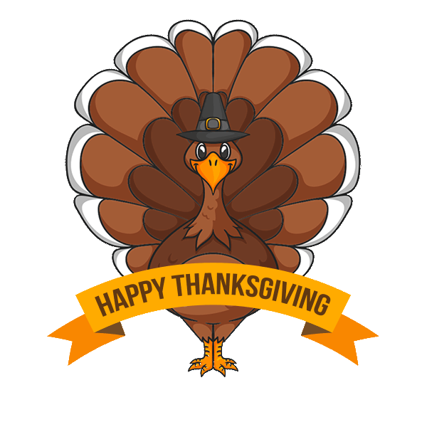 | 24  ALL WEEK | 25
26  *Hanging of the Green  *Lord’s Supper  *Meal in the CAB  *Lottie Moon Auction | 27 | 28 | 29 | 30

